**Institute of Engineering & Management**

**Department of Computer Science & Engineering**

**Communication Engineering Laboratory for 2nd year 4th semester 2018**

**Code: CS 491**

**Date:** 8/02/18

**ASSIGNMENT- 5**

**Experiment Name:**  Design an astable multivibrator using IC 555.

**Objective:** Designing an astable multivibrator using IC 555 using 2 resistors and 2 capacitors

**Theory:** An astable multivibrator, often called a free-running multivibrator, is a rectangular-wave generating circuit. This circuit does not require any external trigger to change the state of the output, hence the name free-running.

**Circuit Diagram:**

**Circuit Operation:** In figure, when Q is low or output VOUT is high, the discharging transistor is cut-off and the capacitor C begins charging toward VCC through resistances RA and RB. Because of this, the charging time constant is (RA + RB) C. Eventually, the threshold voltage exceeds +2/3 VCC, the comparator 1 has a high output and triggers the flip-flop so that its Q is high and the timer output is low. With Q high, the discharge transistor saturates and pin 7 grounds so that the capacitor C discharges through resistance RB with a discharging time constant RB C. With the discharging of capacitor, trigger voltage at inverting input of comparator 2 decreases. When it drops below 1/3VCC, the output of comparator 2 goes high and this reset the flip-flop so that Q is low and the timer output is high. This proves the auto-transition in output from low to high and then to low. Thus the cycle repeats. The time during which the capacitor C charges from 1/3 VCC to 2/3 VCC is equal to the time the output is high.

**Thigh = 0.693 (RA + RB) C**

**Tlow = 0.693 RB C**

**Observation Table:**

|  |  |  |  |  |  |  |  |  |  |
| --- | --- | --- | --- | --- | --- | --- | --- | --- | --- |
| **No. of Obs** | **RA**(Ω) | **RB**(Ω) | **Calculated** | | | | **Oscilloscope** | | |
| **Thigh**(ms) | **Tlow**(ms) | **frequency**(Hz) | **Duty Cycle** | **VPP**(V) | **frequency**(Hz) | **Duty Cycle** |
|  |  |  |  |  |  |  |  |  |  |
|  |  |  |  |  |  |  |  |  |  |
|  |  |  |  |  |  |  |  |  |  |
|  |  |  |  |  |  |  |  |  |  |
|  |  |  |  |  |  |  |  |  |  |
|  |  |  |  |  |  |  |  |  |  |

**Waveform:**

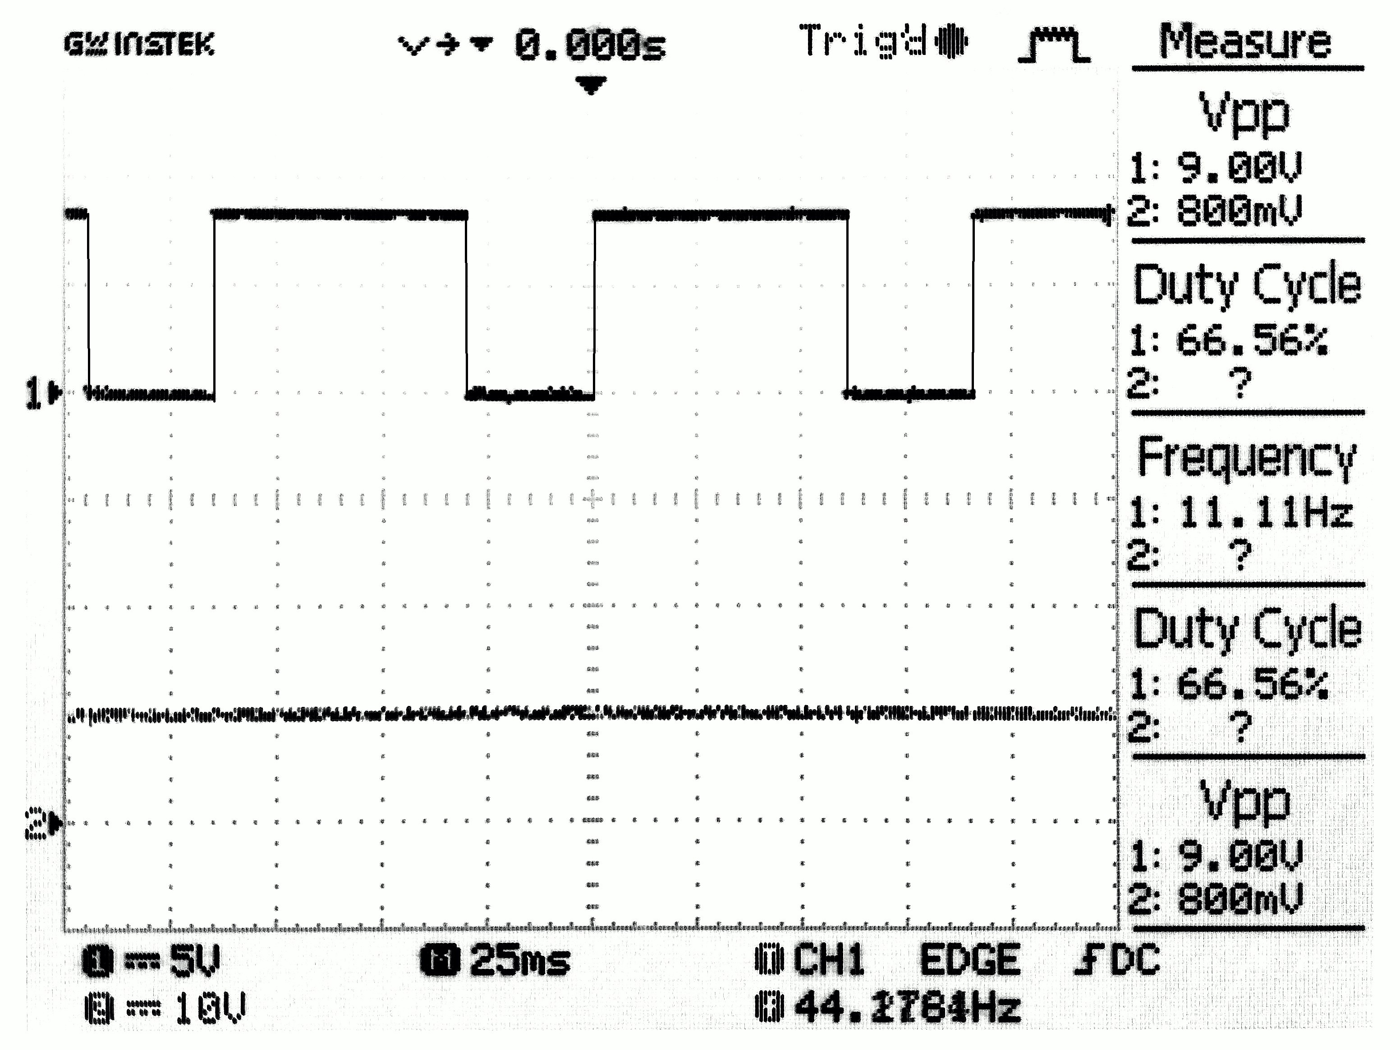

**Discussion:** From this experiment, we came to know about the 555 timer implementations over various purposes including monostable, bistable operations, etc.  
In our circuit, we omitted the diode to get practical duty cycle instead of near 50% duty cycle.